IS312 Web Design and Programming
HOS02A: HTML & CSS
10/09/2024 Reviewed by Sam Chung
5/20/2026 Revised by Jonathan Koerber
09/03/2026 Reviewed by Akshita Modi

School of Technology & Computing (STC)
City University of Seattle (CityU)



Before You Start
In this course, we are going to be using the cloud development environment provided by GitHub Codespaces. The primary reason for this is that it will be a constant environment, so we are sure that our code will run correctly. If you would prefer to work on your local machine, you may need to install some additional packages.
- Some steps may not be explained in detail. If you are not sure what Todo:
- Consult the resources from the course
- Consult an AI chat agent of your choice
- The screenshots provided are examples and may look different depending; however, the overall concept and expected functionality should remain the same.
- If you cannot solve the problem after a few tries, ask a TA for help

Learning Outcomes
- Section 1: Links
- Section 2: Lists
- Section 3: Colors
- Section 4: CSS
- Section 5: Images
- Section 6: Tables
- Section 7: Forms
- Section 8: Videos

AI Learning Workflow
- Be the Architect: Use AI to explain logic or errors.
- Limit Spoilers: Use the 10-Minute Rule to prompt for hints first.
- Audit the Output: Verify AI logic against your actual results.
- Transparency: Add a comment when AI helps solve a complex bug.

Deliverable: Log your AI interactions in your challenge document. Include your specific prompts and reflect on how your phrasing influenced the AI's response

Key Concepts

BASH (Bourne Again SHell) is a command-line interface and scripting language used for file system navigation, running programs, automating tasks, and system administration.

Essential BASH Commands for Web Dev
pwd # Show current directory.
ls # List files,
cd # Change directory,
mkdir # Create directory.
touch # Create file.
cp # Copy files.
mv # Move/rename files.
rm # Remove files.
cat # View file content.
clear # Clear all entered commands.

Mastering these basic BASH commands will make you a more efficient developer and is essential for professional web development workflows.

Recap of HTML and CSS

HTML (HyperText Markup Language) is the foundational language for structuring content on the web. It uses a system of elements and tags to define the various components of a webpage, such as headings, paragraphs, and lists.
- HTML: https://www.w3schools.com/html/

The HTML document is like a tree:
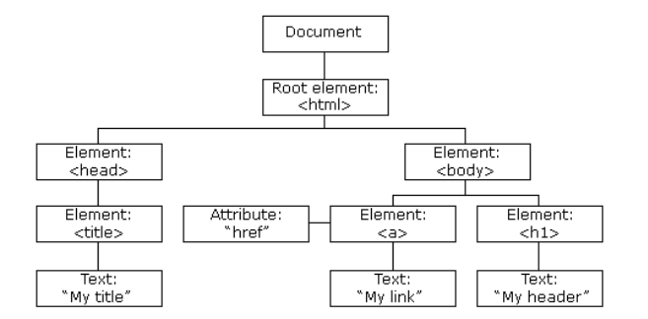
Source: https://www.w3schools.com/whatis/whatis_htmldom.asp

CSS (Cascading Style Sheets) is a fundamental language for styling and visually enhancing web content.
- CSS: https://www.w3schools.com/html/html_css.asp

Refactoring is the process of restructuring existing computer code without changing its external behavior. Its main purpose is to improve the code's internal structure, making it more:
- Readable and maintainable
- Efficient and performant
- Modular and reusable
- Less complex
- Easier to debug and extend

The combination of technical refactoring skills with the focused mindset of vibe coding often leads to higher quality, more maintainable code.
Preparation
- Open your HOS02 assignment in GitHub.
- Create a GitHub Codespace for your project.
- Open the terminal (press “~” and “CTRL” together.)
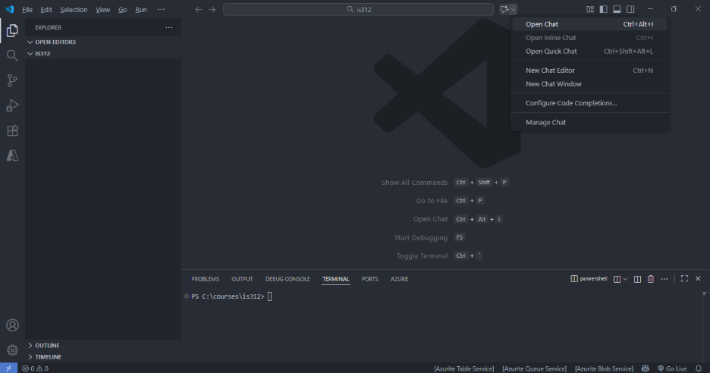

- Open Chat.

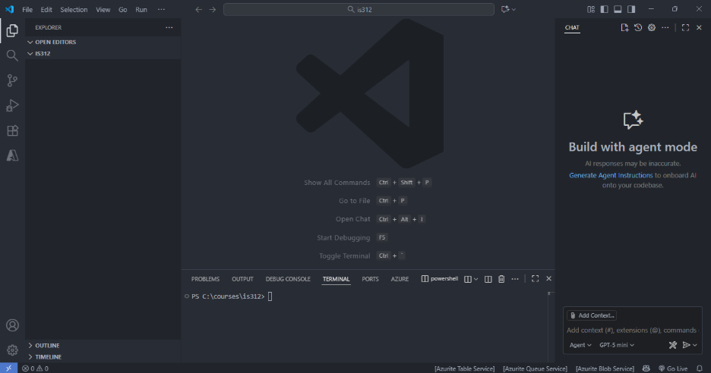
- The current terminal uses Power shell. Let’s change the default terminal to BASH.
- Ctrl+Shift+P → Type: "Terminal: Select Default Profile"
- Select "Git Bash" or "WSL Bash"
- Restart the terminal or open a new terminal window.
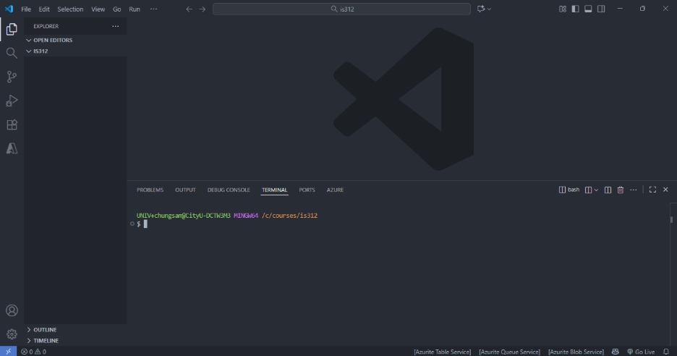

- Ask your chat, “What is the “mkdir” command?” Try to use your conversational AI development Assistant, GitHub Copilot Chat.
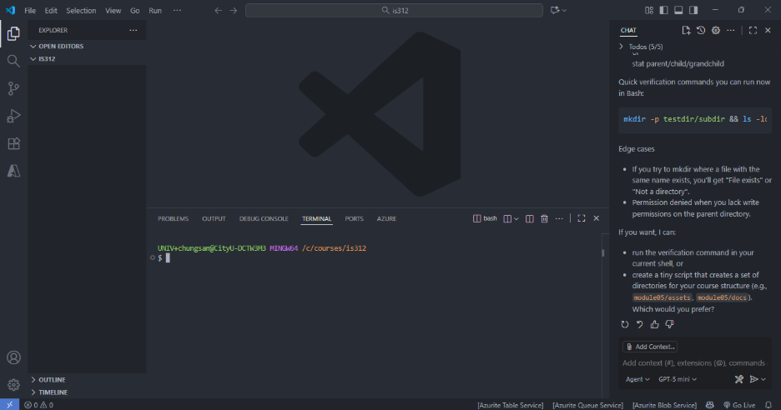

- Create a directory called <directory-name> for eg. “module02” and move into it.
> mkdir <directory-name> for eg.mkdir module02
> cd <directory-name> for eg. cd module02

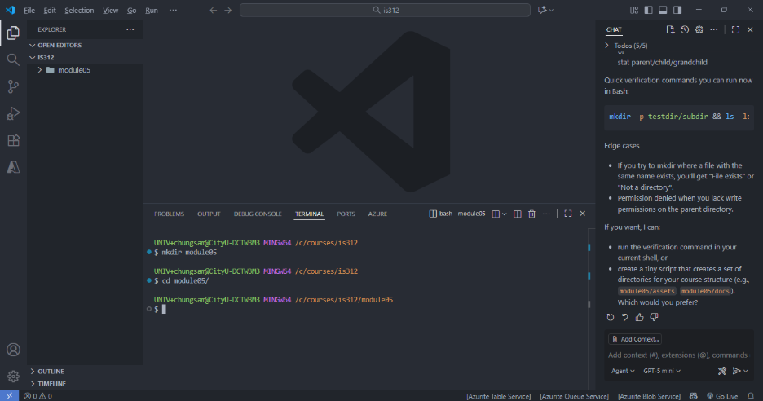

- Clear all commands.
> clear

Section 1: Links
Resources:
- HTML Links Hyperlinks

The HTML <a> tag defines a hyperlink.
<a href="url">link text</a>

- The most important attribute of the <a> element is the href attribute, which indicates the link's destination.
- The link text is the part that will be visible to the reader.
- Clicking on the link text, will send the reader to the specified URL address.

By default, links will appear as follows in all browsers:
- An unvisited link is underlined and blue
- The link visited is underlined and purple
- An active link is underlined and red

Expected Outcome

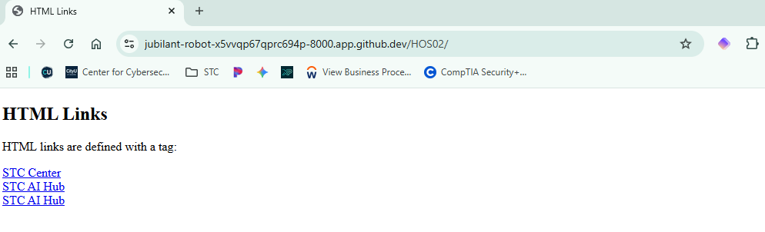

- Create a new HTML file called
> touch <filename>.html for eg. touch m02_01-links.html
The touch command creates an empty HTML file that you can then fill with the HTML code.

- Type the following code into the file. You must use the URL on your website.

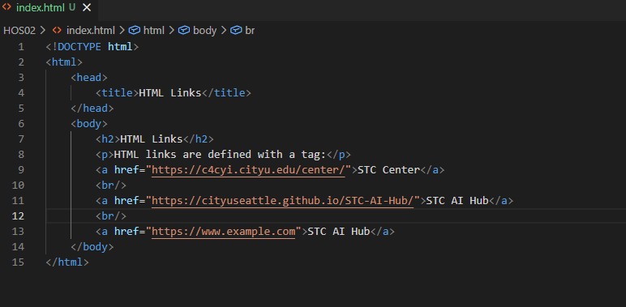

- Let's have a look at how our file has been rendered. We can run a quick http server with Python like we did last week. Run in the terminal “python -m http.server 8000”.

- Play the file with your web browser. Type in the terminal:

- Analyze the source code by using the AI agent to explain how it works.

- Based on the improvement suggestions, improve the source code by using the AI agent. Then, explain what was improved.

- Update the improved source code to show your website in a new browser tab.

Section 2: Lists

Resources:
- HTML Lists

An unordered list starts with the <ul> tag. Each list item starts with the <li> tag.
The “list” items will be marked with bullets (small black circles) by default.
The CSS “list-style-type” property is used to define the style of the list item marker.

Value | Description
disc | Sets the list item marker to a bullet (default)
circle | Sets the list item marker to a circle
square | Sets the list item marker to a square
none | The list items will not be marked

An ordered list starts with the <ol> tag. Each list item starts with the <li> tag.
The “type” attribute of the <ol> tag, defines the type of the list item marker.

Type | Description
type="1" | The list items will be numbered with numbers (default)
type="A" | The list items will be numbered with uppercase letters
type="a" | The list items will be numbered with lowercase letters
type="I" | The list items will be numbered with uppercase roman numbers
type="i" | The list items will be numbered with lowercase roman numbers

Expected Outcome

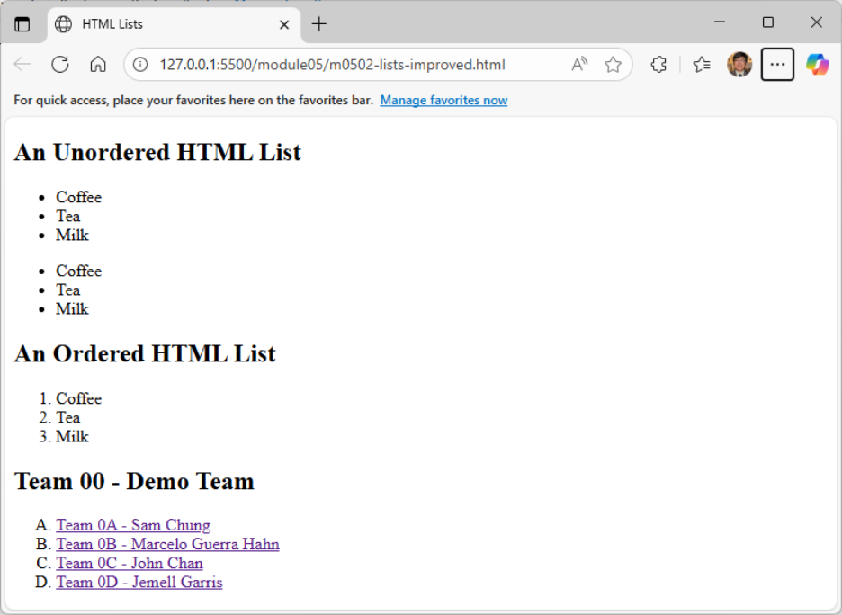

- Create a new html file with the specified filename inside the appropriate module folder for eg. “m0202-lists.html” under the “module02” folder.
> touch <filename>.html for eg. touch m0202-lists.html

- Type the following code into the file. You must use the URL on your website.

- Go to the page that you had for that last exercise. Add a “/” and the name that you named the file so that you can view the

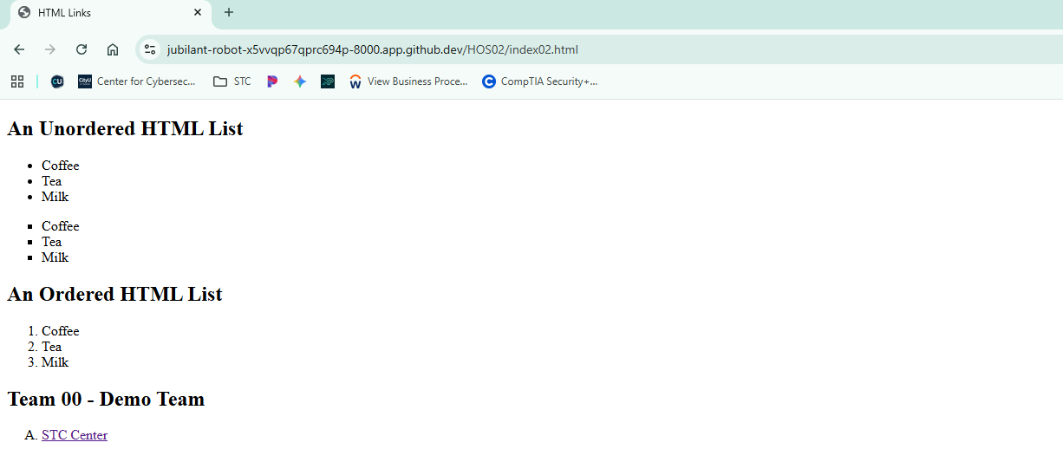

- Analyze the source code by using the AI agent to explain how it works.

- Based on the improvement suggestions, improve the source code by using the AI agent. Then, explain what was improved. Do not include any styles at this moment.

- Update the improved source code to show all your team members’ websites in a new browser tab.

Section 3: Colors
Resources:
- HTML Colors

You can set the color for HTML elements:
- You can set the background color for HTML elements.
<h1 style="background-color:DodgerBlue;">Hello World</h1>
- You can set the color of the text.
<h1 style="color:Tomato;">Hello World</h1>
- You can set the color of borders.
<h1 style="border:2px solid Tomato;">Hello World</h1>

HTML colors are specified with predefined color names, or with RGB, HEX, HSL, RGBA, or HSLA values.
We focus on HEX values.

In HTML, a color can be specified using a hexadecimal value in the form: #rrggbb
Where rr (red), gg (green) and bb (blue) are hexadecimal values between 00 and ff (same as decimal 0-255).
- For example, #ff0000 is displayed as red, because red is set to its highest value (ff), and the other two (green and blue) are set to 00.
- Another example, #00ff00 is displayed as green, because green is set to its highest value (ff), and the other two (red and blue) are set to 00.
- To display black, set all color parameters to 00, like this: #000000.
- To display white, set all color parameters to ff, like this: #ffffff.
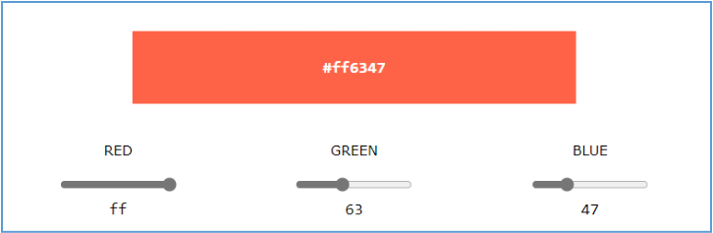
Expected Outcome
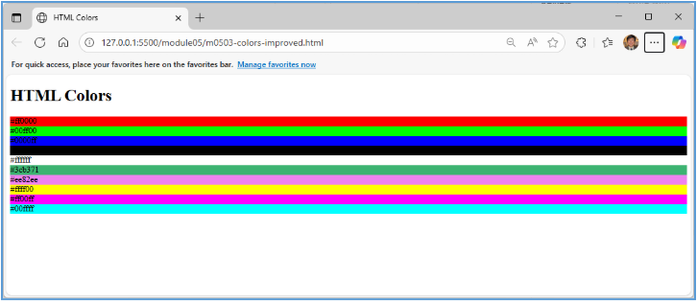

- Create a new html file with the specified filename inside the appropriate module folder for eg. “m02-03-colors.html” under the “module02” folder.

- Type the following code into the file.
VS Code has native support for color visualization that shows small color swatches next to hex codes, RGB values, and other color formats

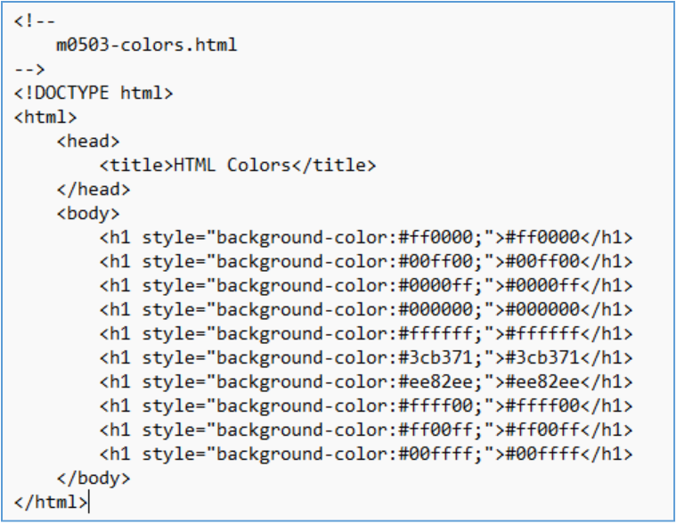

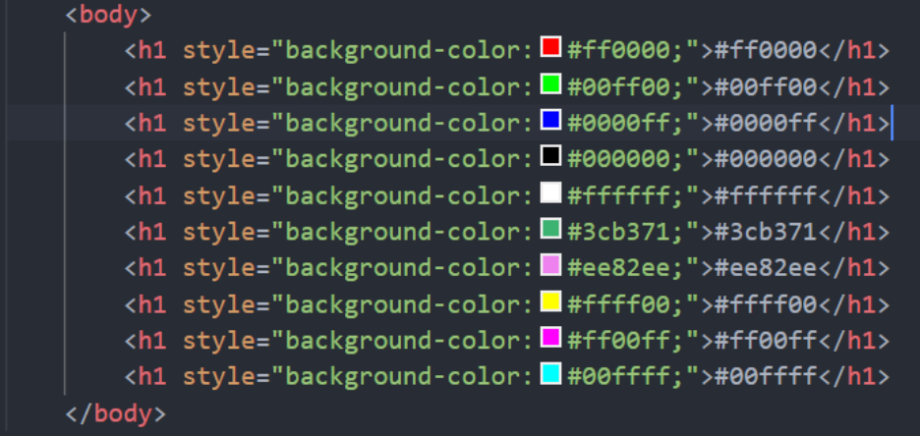

- Select the file and press it with your right mouse button. Select the “Open with Live Server.”
- Play the file with your web browser.
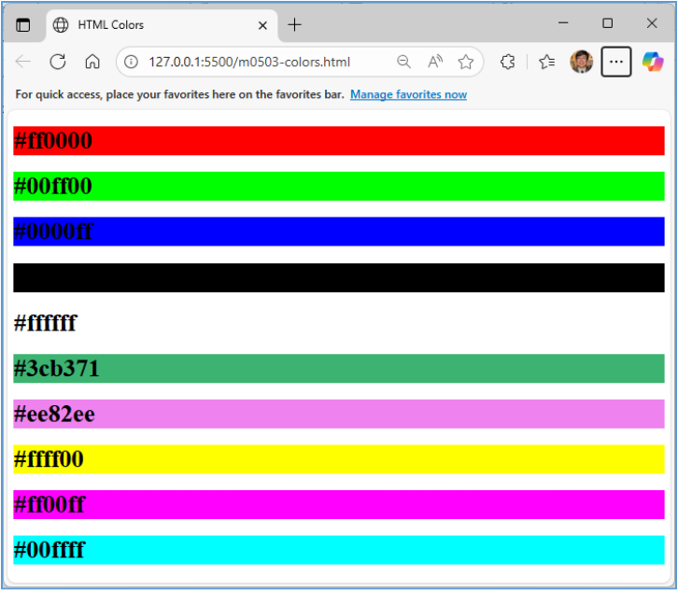

- Analyze the source code by using the AI agent to explain how it works.
- Based on the improvement suggestions, improve the source code by using the AI agent. Accept the minimal changes. Then, explain what was improved. Do not include any styles at this moment except for the given inline styles. For example,

- Update the improved source code to show the four colors that each team member will use. For this question, each member must select his or her favorite color.

Section 4: CSS

Resources:
- HTML Styles CSS
- CSS Syntax

Cascading Style Sheets (CSS) is used to format the layout of a webpage.
- With CSS, you can control the color, font, the size of text, the spacing between elements, how elements are positioned and laid out, what background images or background colors are to be used, different displays for different devices and screen sizes, and much more!
- The word cascading means that a style applied to a parent element will also apply to all children's elements within the parent.
- CSS can be added to HTML documents in 3 ways:
  - Inline - by using the style attribute inside HTML elements.
  - Internal - by using a <style> element in the <head> section.
  - External - by using a <link> element to link to an external CSS file.
- We mainly focus on external CSS. External style sheets can be referenced with a full URL or with a path relative to the current web page.

A CSS rule consists of a selector and a declaration block.

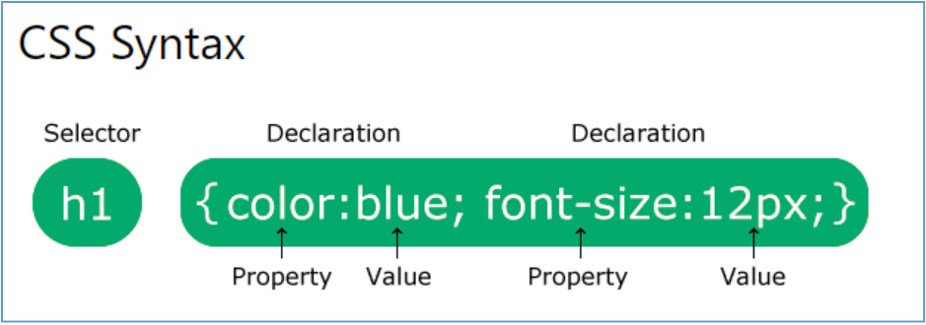

- The selector points to the HTML element you want to style.
- The declaration block contains one or more declarations separated by semicolons.
- Each declaration includes a CSS property name and a value, separated by a colon.
- Multiple CSS declarations are separated with semicolons, and declaration blocks are surrounded by curly braces.

An external CSS example: styles.css
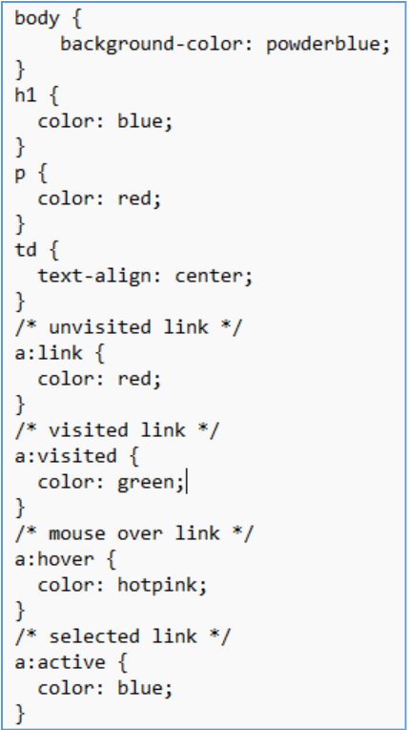

Expected Outcome

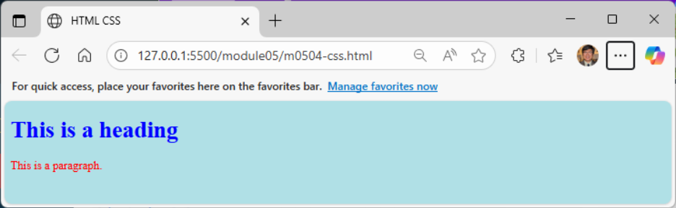

- Create a new html file with the specified filename inside the appropriate module folder for eg. “m02-04-css.html” and a “styles.css” under the “module02” folder.

- Type the following code into the HTML file.

- The “styles.css” file is provided above.

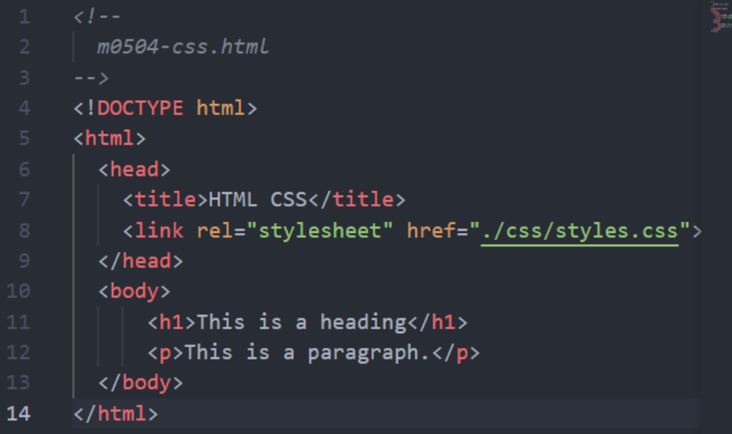

- Select the HTML file and press it with your right mouse button. Select the “Open with Live Server.”

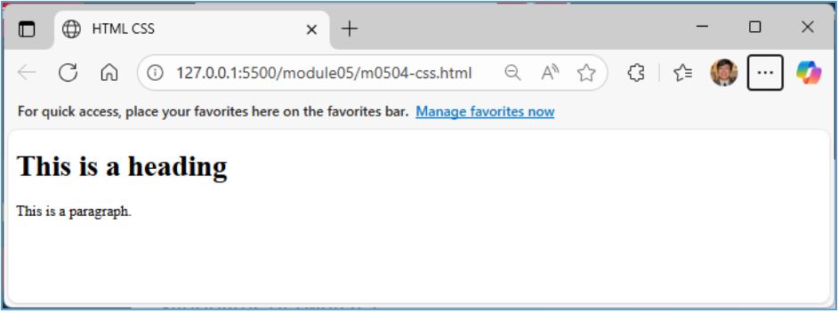

- Change the name of the file in your browser like before.
- Analyze the source code by using the AI agent to explain why the styles were not used.
- Based on the improvement suggestions, improve the source code by using the AI agent. Let your Agent create the “styles” directory.

- Accept the minimal changes. Then, explain what was improved.

Section 5: Images

Resources:
- HTML Images

Images are not technically inserted into a web page; images are linked to web pages.
- The <img> tag creates a holding space for the referenced image.
- The <img> tag is empty, it contains attributes only and does not have a closing tag.
- The <img> tag has two required attributes:
  - src - Specifies the path to the image
  - alt - Specifies an alternate text for the image

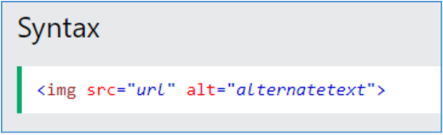

Expected Outcome

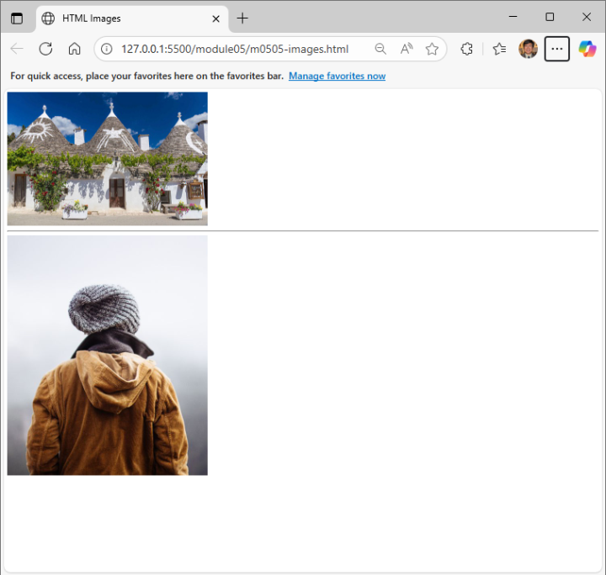

- Create a new html file with the specified filename inside the appropriate module folder for eg. “m0205-images.html” under the “module05” folder.

- Type the following code into the file.
  - Two image files (img_girl.jpg and pic_trulli.jpg) are provided.
  - However, you have to place them correctly.

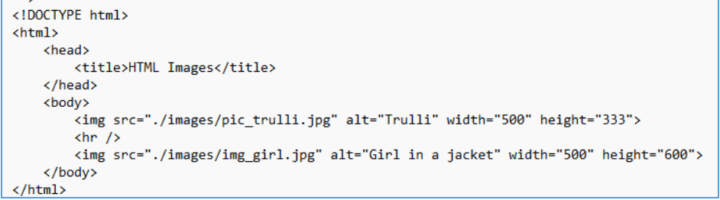

- Select the file and press it with your right mouse button. Select the “Open with Live Server.”
- Play the file with your web browser.

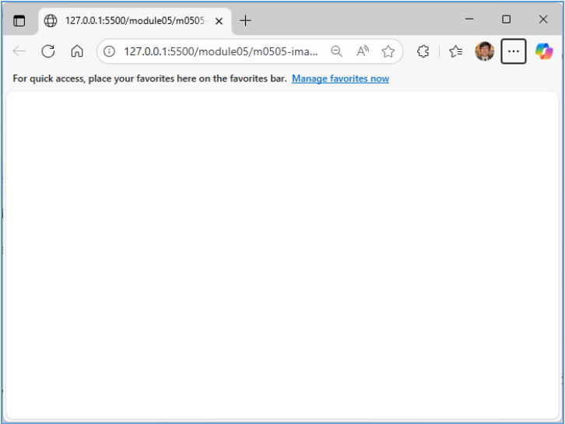

- Analyze the source code by using the AI agent to explain how it does not work. Let the AI agent fix it.

- Based on the improvement suggestions, improve the source code by using the AI agent. Accept the minimal changes. Then, explain what was improved.

Section 6: Tables

Resources:
- HTML Tables

A table cell can contain all sorts of HTML elements: text, images, lists, links, other tables, etc.
A table in HTML consists of table cells inside rows and columns.
- Table headers are defined with the elements. Each element represents a table cell.
- Table Row: Each row is defined by a <tr> and a </tr> tag.
- Table Data: Each table cell is defined by a <td> and a </td> tag.
- To add a border, use the CSS border property on table, th, and td elements.
- To set the width of a table, add the style attribute to the <table> element:

Expected Outcome

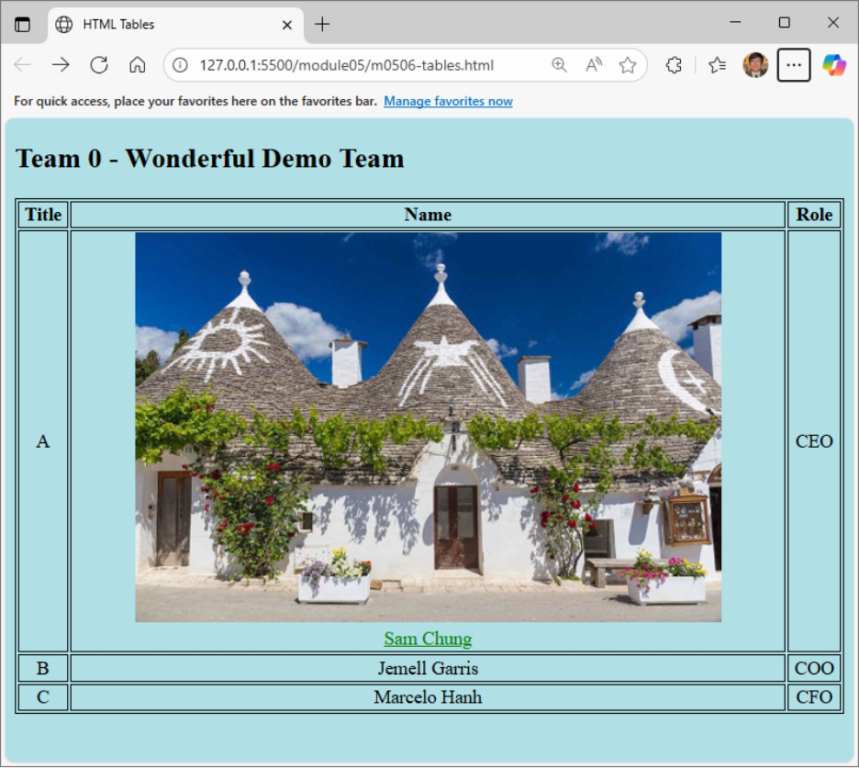
- Create a new html file with the specified filename inside the appropriate module folder for eg. “m0506-tables.html” under the “module05” folder.

- Type the following code into the file.
  - A local image file is used. You have to place them correctly in the images folder.
  - Internal and external styles are used.

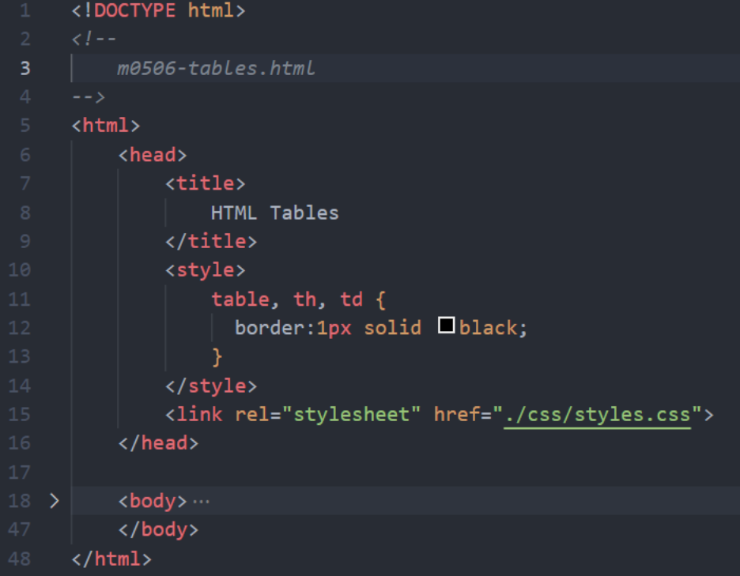

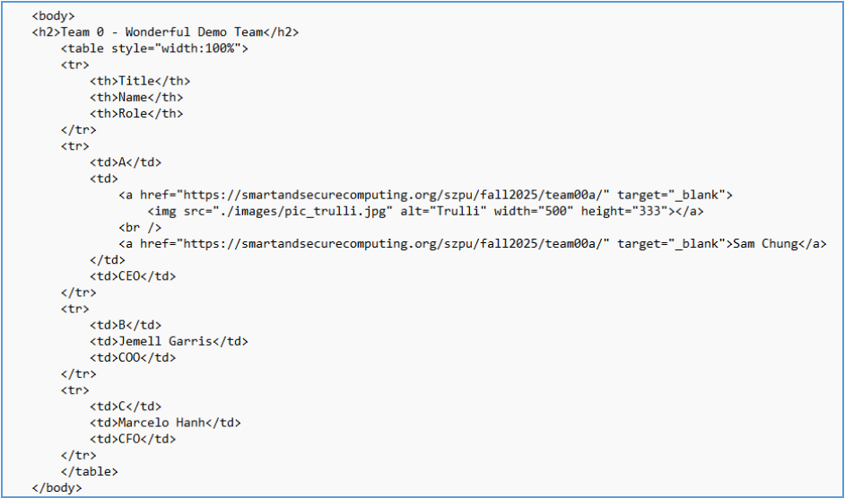

- Select the file and press it with your right mouse button. Select the “Open with Live Server.”
- Play the file with your web browser.
- Analyze the source code by using the AI agent to explain how it works.
- Based on the improvement suggestions, improve the source code by using the AI agent. Accept the minimal changes. Then, explain what was improved.
- Update the improved source code to show your team’s information. Use each member's profile picture and URL.
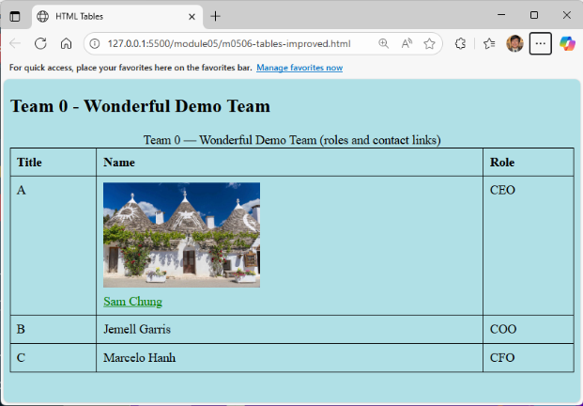
Section 7: Forms
Resources:
- HTML Forms

An HTML form is used to collect user input. The user input is most often sent to a server for processing.

The <form> element is a container for different types of input elements, such as text fields, checkboxes, radio buttons, submit buttons, etc.
- The action attribute defines the action to be performed when the form is submitted.
- The target attribute specifies where to display the response that is received after submitting the form.

The HTML <form> element can contain one or more of the following form elements:
- <input>
- <label>
- <select>
- <textarea>
- <button>
- …

The HTML <input> element is the most used form element.
- An <input> element can be displayed in many ways, depending on the type of attribute.
- There are many different types of input elements.
  - <input type="button">
  - <input type="checkbox">
  - <input type="date">
  - <input type="datetime-local">
  - <input type="email">
  - <input type="password">
  - <input type="radio">
  - <input type="reset">
  - <input type="submit">
  - <input type="text">
  - …

Expected Outcome

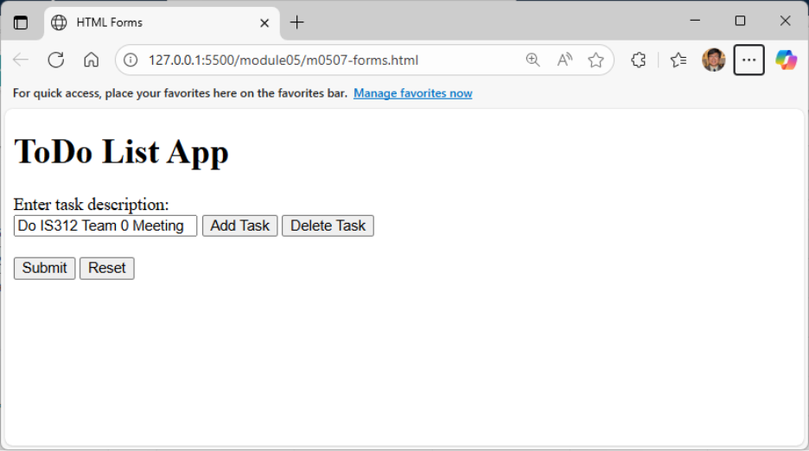

- Create a new html file with the specified filename inside the appropriate module folder for eg. “m0507-forms.html” under the “module05” folder.

- Type the following code into the file.

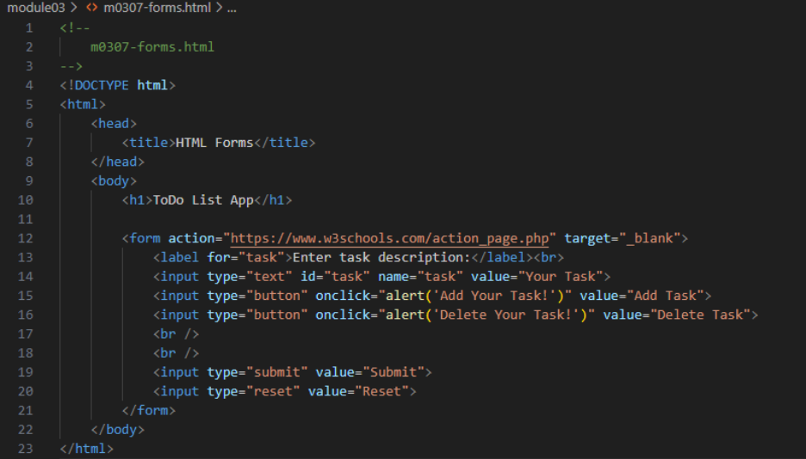

- Select the file and press it with your right mouse button. Select the “Open with Live Server.”
- Play the file with your web browser.
- Analyze the source code by using the AI agent to explain how it works. Explain why this is a distributed application?
- Based on the improvement suggestions, improve the source code by using the AI agent. Accept the minimal changes. Then, explain what was improved.
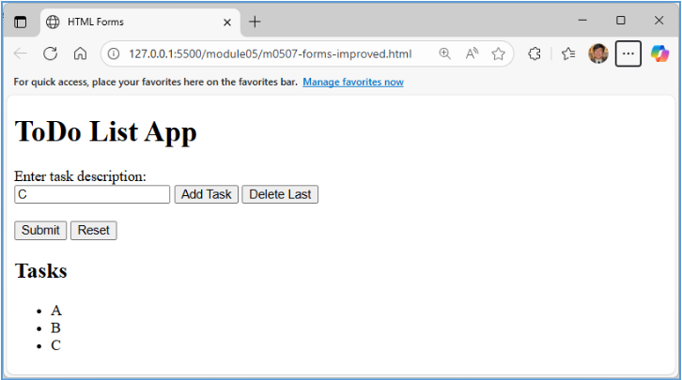

Section 8: Videos

Resources:
- HTML Video

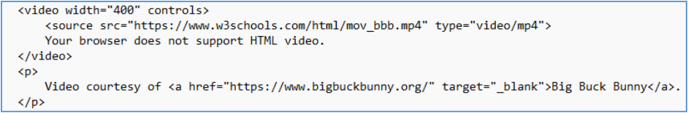

- The controls attribute adds video controls, like play, pause, and volume. It is a good idea to always include width and height attributes. If height and width are not set, the page might flicker while the video loads.
- The <source> element allows you to specify alternative video files which the browser may choose from. The browser will use the first recognized format.
- The text between the <video> and </video> tags will only be displayed in browsers that do not support the <video> element.

Expected Outcome

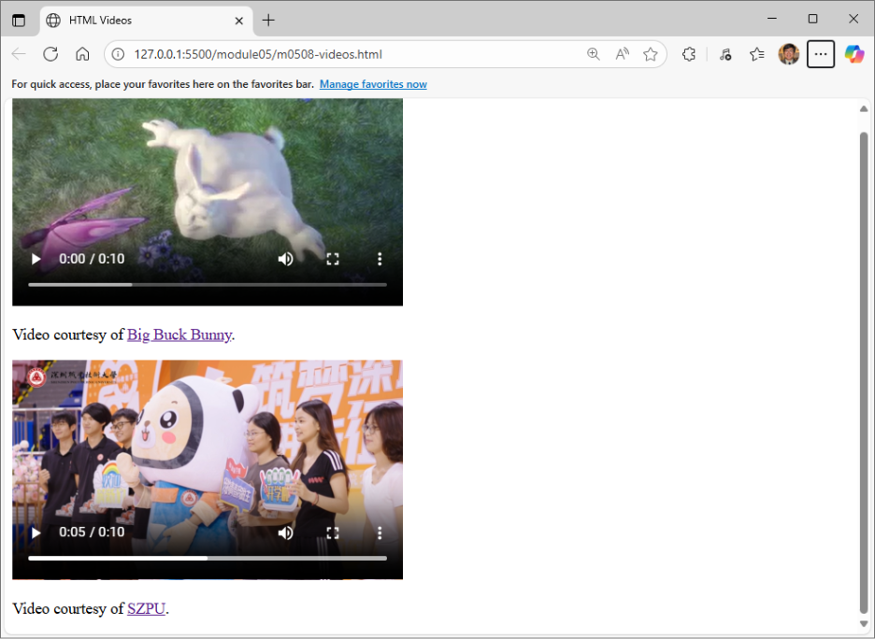

- Create a new html file with the specified filename inside the appropriate module folder for eg. “m0508-videos.html” under the “module05” folder.

- Type the following code into the file.
  - Two video links are used.
  - The SZPU video (szpu_marketing.mp4) is placed under the “videos” directory.
Note: If szpu_marketing.mp4 is unavailable, use an MP4 video of your choice. Place the video in the videos directory and replace the filename in the <source> element with your video's filename.

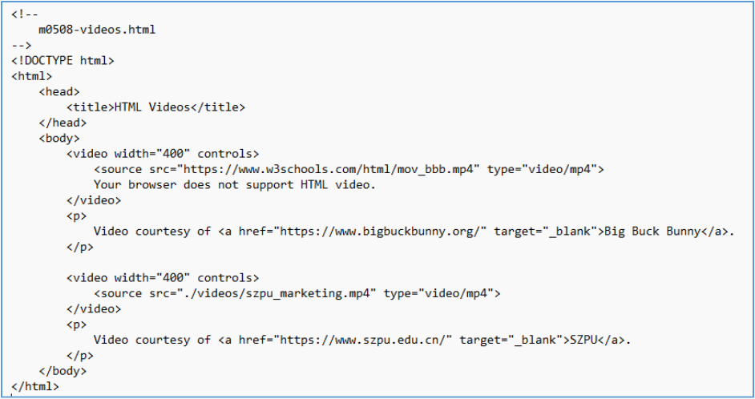

- Select the file and press it with your right mouse button. Select the “Open with Live Server.”
- Play the file with your web browser.
- Analyze the source code by using the AI agent to explain how it works.
- Based on the improvement suggestions, improve the source code by using the AI agent. Accept the minimal changes. Then, explain what were improved.

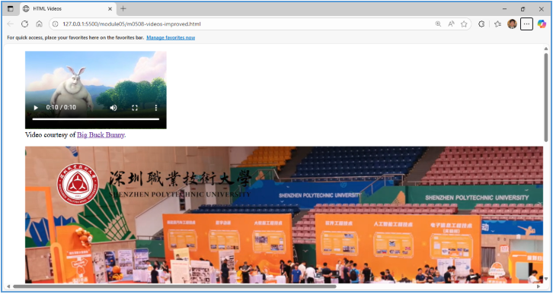

Section 9: Module 05 Tree

- By using your AI agent, create the structure of module05. For example,
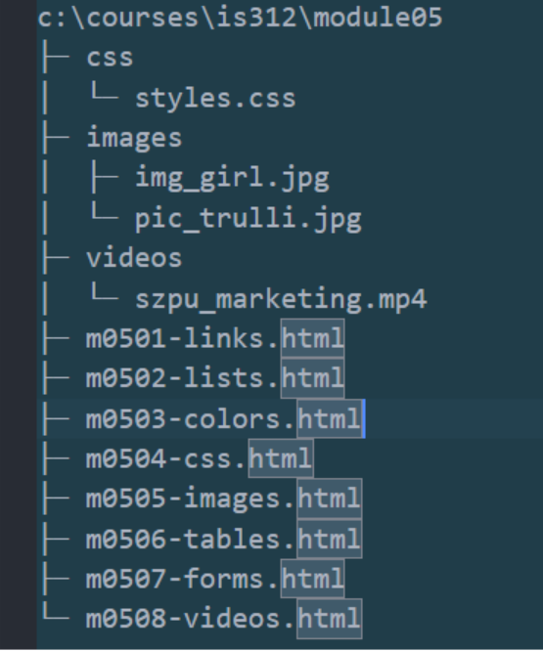

- While studying HTML and CSS, you created separate directories for different file extensions to implement the Separation of Concerns (SoC). For instance, you have a "styles" directory for .css files, an "images" directory for .jpg files, and a "videos" directory for .mp4 files. Is this a good approach?

Push commit a push your work:

1. In the terminal run the command to add changes git add --all
2. Commit changes by git commit –m “chages for HOS02”
3. Push changes. git push

